Lifestyle
http://www.uspa24.com/bericht-12823/le-salon-de-la-patisserie-for-the-first-time-in-paris-exposed-as-an-art.html
LE SALON DE LA PATISSERIE FOR THE FIRST TIME IN PARIS EXPOSED AS AN ART
JUNE 15-16-17 AT PORTE DE VERSAILLES
Responsible Author: Ruby BIRD & Yasmina BEDDOU (Journalists/Directors) | PARIS, 02/16/2018, 11:36 Time | 22388x read
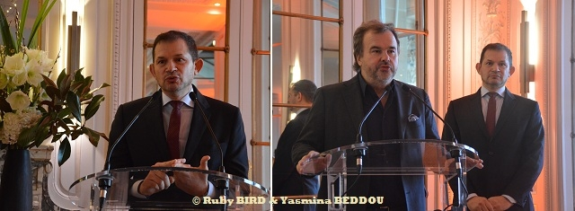
Press Conf. First Salon de la Patisserie in Paris | Source: © Ruby BIRD & Yasmina BEDDOU
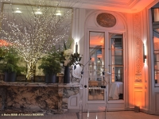
Press Conf. First Salon de la Patisserie in Paris
Source: © Ruby BIRD & Yasmina BEDDOU
USPA NEWS - For the First Time (June 15-16-17, 2018) in Paris and by extention in FRANCE, will be held LE SALON DE LA PATISSERIE, a Tribute to this Great Art recognized worldwide, specially the French Pâtisserie. France is a Paradise for all Gourmets and Paris, a Great City for all Pastry and Chocolate Lovers looking for new Flavors Experiences....
For the First Time (June 15-16-17, 2018) in Paris and by extention in FRANCE, will be held LE SALON DE LA PATISSERIE, a Tribute to this Great Art recognized worldwide, specially the French Pâtisserie. France is a Paradise for all Gourmets and Paris, a Great City for all Pastry and Chocolate Lovers looking for new Flavors Experiences.... The French Pastry Specialities are under our eyes : Eclairs, Saint-Honorés, Paris-Brest, tartes au citron meringuée…They are all Colored, Elegant and above all Very Appetizing.
Le Salon De La Pâtisserie, to be Special is Sponsored by Pierre HERME : a French Pastry Chef and Chocolatier. He began his Career at the age of 14 as an Apprentice to Gaston Lenôtre. He was awarded the Title of World's Best Pastry Chef in 2016 by the World's 50 Best Restaurants and as the 4th Most Influential French Person in the World by Vanity Fair in 2016. Pierre Hermé created his Own Brand in 1998 with Charles Znaty. The Company has been expanding strongly since 2010 on the International Scene with several Boutiques now located in Europe, Asia and the Middle East. Preferring discreet Pastry Decors and "uses Sugar like Salt, in other words, as a seasoning to heighten other shades of flavour" and refusing to sit on his Laurels, he is always revising his Own Work, exploring new Taste Territories and revisiting his Own Recipes. Pierre Hermé was the Youngest Person to be named France's Pastry Chef of the Year, and is the only Pastry Chef to have been decorated as a Chevalier of Arts and Letters. He was awarded "Chevalier de la Légion d'honneur" by Jacques Chirac in May 2007
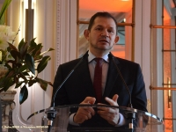
Zakari BENKHADRA
Source: © Ruby BIRD & Yasmina BEDDOU
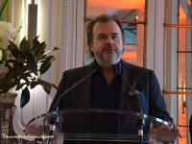
Pastry Chef Pierre HERME
Source: © Ruby BIRD & Yasmina BEDDOU
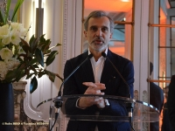
Thierry MARQUES
Source: © Ruby BIRD & Yasmina BEDDOU

This Event was for a Long Time the Dream of Zakari BENKHADRA, Founder and President of Sweet Event. After having spent years in the Gastronomy Industry, he decided to focus on the Pastry Industry. His love for those Two Sectors brought him to dedicate his Life to Promote them up to this First Salon De La Pâtisserie.
"Pâtisserie is an Art and like All Arts, gets Exposed".
Food is an Art Form, an Expression of Oneself, an Outlet for Creativity. Not all Artists have the Fortune of basing their Career off of their Art Form, but when your Art Form consists of Little Morsels of Delight, Beautiful Sculptures made of Butter and Sugar, and Chemistry Experiments that end up in Little Miracles, it’s not hard to believe that a Pastry Artist could have a successful Business in a Booming City.
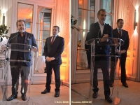
Press Conf. First Salon de la Patisserie in Paris
Source: © Ruby BIRD & Yasmina BEDDOU
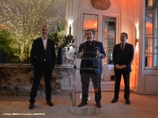
Press Conf. First Salon de la Patisserie in Paris
Source: © Ruby BIRD & Yasmina BEDDOU
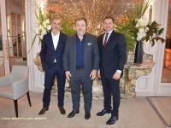
Press Conf. First Salon de la Patisserie in Paris
Source: © Ruby BIRD & Yasmina BEDDOU

Three Days of Discovery at Le Salon De La Pâtisserie :
* 6,000 Square Meter
* 50,000 Visitors expected
* 13 Regions represented
* 500 Attendees
* 200 Exhibitors
* 10 Master Classes
* 50 Pastry Workshops
* 5 "Univers" to Discover, Meet and Taste
* 2 Official Competitions
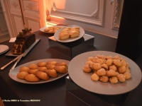
Lenôtre Pastries
Source: © Ruby BIRD & Yasmina BEDDOU
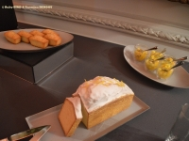
Lenôtre Pastries
Source: © Ruby BIRD & Yasmina BEDDOU
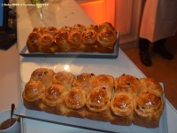
Lenôtre Pastries
Source: © Ruby BIRD & Yasmina BEDDOU

A Special Focus will be given to CHILDREN called "Original Flavors" through :
* Workshops
* Competitions (age 6-13)
* Education with Taste & Health Passeport
* Funny and Delicious Entertainments
* Awards and Gifts
Trend : "Sweet Art" regarding Art & Pâtisserie :
* Demonstrations of Famous Chefs
* Competitions of creative Pâtisseries
* Sugar, Chocolate and Icy Sculptures
* Show "Art Performance"
Tradition "La French Touch" regarding Crafts and Terroirs :
* Competitions on Croquembouches, Pièces Montées, Buffets Sucrés, Pains de Décors...
* Event Decorating Rooms
* Competitions on Cakes, Jams, Madeleines... Drawings
* Tasting of Pâtisseries and Chocolate around WIne, Teas, Coffees...
* Popular Dance "Bal Musette" and Tea Dance
Sweet Workshops "L'Atelier des Douceurs" :
* Visit of Famous Chefs giving their Advice and Help
* Certificates
* Several Awards to Advanced Amateurs
The Forum "Master Class" (Area of Exchange and Share) :
* Masterful Demonstrations
* Symposium around Scientists, technicians, Academics...
* Signatures of Art Pastry Chef
* Live TV and Radio
Source : Press Conference on February 14, 2018 @ Automobile Club de France (Paris).
Salon De La Pâtisserie June 15-16-17, 2018 @ Porte De Versailles (Paris)
Ruby BIRD
http://www.portfolio.uspa24.com/
Yasmina BEDDOU
http://www.yasmina-beddou.uspa24.com/

